Pro Hac Vice Admission
The following steps may be completed before a pro hac vice motion is filed; however, E-Filing privileges will NOT be granted until a motion has been approved by the Court.

Per Local Rule 83.2 and Local Criminal Rule 57.2, you must file a motion for pro hac vice admission for each attorney in CM/ECF along with the applicable fee. The motion may be filed in paper, by a sponsoring attorney, or electronically by the moving attorney if said attorney was previously admitted pro hac vice in another case.

 | Action | Screenshot
1 | Login to www.pacer.gov  Hover over Manage My Account | 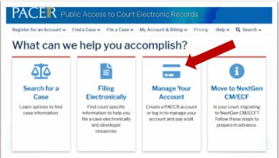
2 | Click on Manage My Account Login | 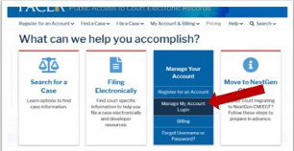
3 | Click on the Log in to Manage My Account
4 | Enter username/password | 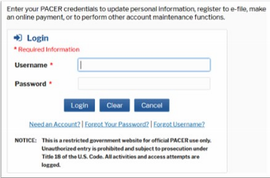
5 | Click Login
6 | Select the Maintenance tab and click Attorney Admissions/E-File Registration | 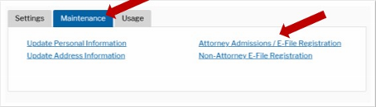
7 | Select U.S. District Courts as the Court Type and Kentucky Western District Court as the Court. Click Next. | 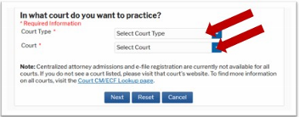
8 | Select Pro Hac Vice | 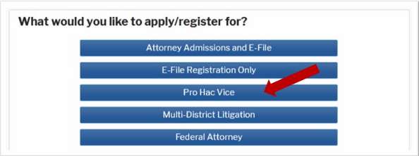
9 | Review/complete the personal information on the E-File Registration screen. | 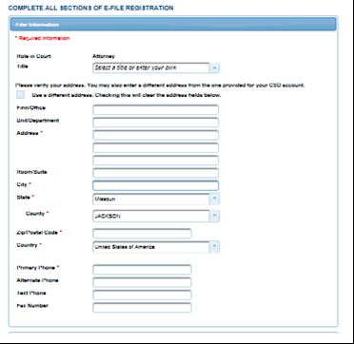
10 | Enter the Case Number in the Western District of Kentucky for the case in which you are proceeding Pro Hac Vice and click Next.  NOTE: HTML is the preferred Email Format | 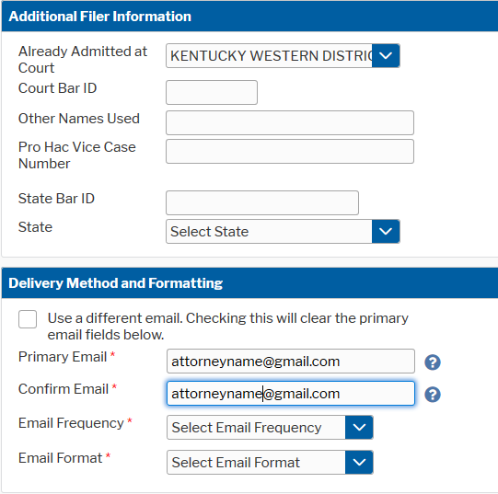
11 | Set default Payment Information if desired (not required). Click Next when finished or to bypass this screen. You can add a credit card or ACH payment method for each of the following fee types: | 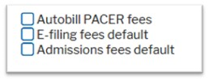  To use the same account for multiple fee types, once account information is entered, click in the box next to one or multiple fee types to designate the entered payment method for that account.
12 | Check the two boxes for Acknowledgment of E-filing Terms and Conditions and Court Policies and Procedures for Attorney Admissions.
13 | Click Submit. The court will review your admission request and provide you with further instructions by email, if necessary. | 